FIXED INCOME PORTFOLIO RISK MODELING
Nelson-Siegel Yield Curve Dynamics and Multi-Factor VaR
Quantitative Research Project | Fixed Income Risk Management

ABSTRACT

This project builds a risk measurement model for fixed income portfolios using multi-factor decomposition, Nelson-Siegel yield curve modeling, and Monte Carlo simulation. The approach combines Principal Component Analysis of yield changes, credit spread dynamics, and term structure evolution to produce risk estimates. Applied to a diversified fixed income portfolio (BIL, SHY, IEF, TLT, LQD, HYG), the model produces a 99% Value-at-Risk of 1.24% and CVaR of 1.40%, broken down by duration, convexity, and credit factors. Historical stress testing is used to validate the model against the 2008 Financial Crisis and the 2020 COVID-19 shock.

Key Risk Metrics at a Glance
Metric | Value
Portfolio Coverage | January 2005 – December 2024 (5,271 observations)
NS-Driven Monte Carlo VaR (99%) | 1.24%
NS-Driven Monte Carlo CVaR (99%) | 1.40%
Historical VaR (99%) | 0.96%
Baseline PCA Monte Carlo VaR (99%) | 0.84%
Parallel +100 bps Shock : Estimated Loss | 6.04%
2008 Crisis : Worst Single-Day Loss | 2.53%
COVID-19 Crash : Worst Single-Day Loss | 2.95%

1. Portfolio Construction and Data

The analysis portfolio comprises six fixed income ETFs representing the full term structure and credit spectrum. Portfolio weights (5%, 20%, 25%, 15%, 20%, 15%) reflect a barbell strategy combining short-term safety with higher-yielding intermediate/long bonds, while maintaining meaningful credit exposure. This allocation targets 4–6 year effective duration with moderate credit spread sensitivity.

ETF Composition
• BIL (1–3 Month T-Bills) : 5% weight: Ultra-short duration (0.08–0.25 years), risk-free benchmark. Acts as cash proxy with daily liquidity and minimal interest rate sensitivity. The allocation serves as portfolio ballast (uncorrelated with duration/credit risk), a liquidity reserve, and provides a modest yield enhancement over overnight cash.
• SHY (1–3 Year Treasuries) : 20% weight: Short duration, low interest rate risk.
• IEF (7–10 Year Treasuries) : 25% weight: Intermediate duration, core portfolio exposure.
• TLT (20+ Year Treasuries) : 15% weight: Long duration, high convexity.
• LQD (Investment Grade Corporate) : 20% weight: Credit risk premium.
• HYG (High Yield Corporate) : 15% weight: Elevated default risk.

Data Coverage
Daily price data spans January 2005 to December 2024 (5,271 observations), covering multiple interest rate cycles: the Zero Lower Bound period (2009-2015), Taper Tantrum (2013), rate normalization (2015-2019), COVID-19 response (2020), and aggressive tightening (2022-2023). This date range includes several structural regime changes in fixed income markets.
Yield curve data comprises Treasury constant maturity rates at 3-month, 5-year, 10-year, and 30-year tenors from the Federal Reserve H.15 release (accessed via Yahoo Finance proxies). These tenors provide sufficient granularity to capture parallel shifts, slope changes, and curvature movements in the term structure.

2. Factor Decomposition via Principal Component Analysis

Fixed income returns are driven primarily by systematic yield curve movements. PCA is applied to daily yield changes across four maturities to extract orthogonal risk factors. The three-factor structure is consistent with the academic literature (Litterman–Scheinkman, 1991) and industry practice.

PCA Results : Explained Variance
Metric | Value
Factor 1 : Level (parallel shifts) | 89.9% of yield variance
Factor 2 : Slope (short vs. long rate divergence) | 9.4% of yield variance
Factor 3 : Curvature (butterfly movements) | 0.7% of yield variance

Economic Interpretation
Factor 1 (Level) represents monetary policy stance and inflation expectations. Its dominant loading (89.9%) confirms that most yield movements are parallel shifts driven by Federal Reserve policy signals.
Factor 2 (Slope) captures term premium and growth expectations. Positive slope shocks (curve steepening) occur during economic expansion; negative shocks (flattening) signal recession fears or policy tightening.
Factor 3 (Curvature) reflects supply-demand imbalances and convexity hedging. This factor explains tactical movements where intermediate maturities (5–10 year) diverge from the short and long ends, often due to Treasury auction cycles or mortgage prepayment hedging.

3. Credit Spread Factor

Beyond Treasury yield movements, corporate bonds face credit spread risk. A credit factor is constructed as the return differential between LQD (investment grade corporates) and IEF (matched-duration Treasuries):
Credit Spread Factor = Return(LQD) − Return(IEF)
This spread captures changes in credit risk premiums orthogonal to interest rate movements. The credit factor is particularly relevant during economic stress: during the 2008 Crisis, LQD-IEF spreads widened by over 600 basis points, dominating interest rate effects.

4. Multi-Factor Regression Model

Each ETF's return sensitivity to the four systematic factors (F1, F2, F3, Credit Spread) is estimated via OLS regression:
R(ETF,t) = α + β₁·F1(t) + β₂·F2(t) + β₃·F3(t) + β₄·Spread(t) + ε(t)

Key Factor Loadings (Betas)
Metric | Value
BIL : F1 / F2 / F3 / Spread | 0.00486 / 0.00273 / −0.01121 / −0.01689
SHY : F2 (slope exposure) | 0.73
IEF : F2 (intermediate duration) | 4.31
TLT : F2 / F3 (long duration + convexity) | 8.84 / 11.29
LQD : F2 / Credit Beta | 4.31 / 0.99
HYG : F1 / F3 / Credit Beta | 0.073 / −4.13 / 0.93

Economic Interpretation
The beta structure validates portfolio construction logic. Short-duration assets (BIL, SHY) exhibit minimal interest rate sensitivity : BIL's factor loadings are 50–100x smaller than those of other ETFs, reflecting its money market characteristics. Its contribution to total portfolio variance is less than 0.1% despite its 5% weight.
Long-duration TLT shows extreme slope and curvature exposure due to its high convexity (duration approximately 18–20 years). Credit-sensitive ETFs (LQD, HYG) show near-unit exposure to the spread factor (0.99, 0.93), confirming that credit spread changes pass through one-for-one to returns. HYG's negative curvature loading reflects its hybrid equity-bond behaviour during stress episodes.
Residual standard errors range from 0.01% (BIL) to 0.15% (HYG), with corporate bonds exhibiting higher idiosyncratic volatility due to issuer-specific credit events.

5. Nelson-Siegel Yield Curve Modeling

PCA factors describe realized yield movements, but risk estimation also requires modeling how the term structure evolves over time. The Nelson-Siegel (1987) parametric yield curve is used for this purpose:
y(m) = β₀ + β₁·[(1 − e^(−m/λ)) / (m/λ)] + β₂·[(1 − e^(−m/λ)) / (m/λ) − e^(−m/λ)]
where: m = maturity (years), β₀ = long-run level, β₁ = short-term component, β₂ = medium-term component, λ = decay parameter
NS parameters are fitted monthly to the four observed yields (3M, 5Y, 10Y, 30Y) using nonlinear least squares with warm-start initialization, producing a time series of 252 monthly parameter vectors spanning the full sample period.

Rationale for Nelson-Siegel
1. Structural Interpretation : Parameters map to economic concepts (level, slope, curvature) with explicit maturity dependence. β₀ represents long-term inflation expectations, β₁ captures short-rate policy, and β₂ reflects term premium dynamics.
2. Smoothness Constraint : The functional form enforces smooth, arbitrage-free yield curves. PCA factor loadings can produce kinked or non-monotonic implied curves, violating no-arbitrage conditions.
3. Extrapolation Capability : NS parameters permit yield forecasting at unobserved maturities (e.g., 2-year, 15-year) and facilitate scenario analysis on the entire term structure rather than just observed points.

6. Monte Carlo Simulation Framework

20,000 simulated scenarios are generated using a four-stage process:

Stage 1 : Nelson-Siegel Parameter Evolution
• Compute daily changes in NS parameters (Δβ₀, Δβ₁, Δβ₂, Δλ)
• Estimate multivariate normal distribution: NS_deltas ~ N(μ_NS, Σ_NS)
• Simulate 20,000 NS parameter shocks from this distribution

Stage 2 : Mapping to PCA Factor Space
For each simulated NS parameter vector:
• Reconstruct implied yield curve using perturbed NS parameters
• Compute yield changes at observed tenors: Δy = y_sim − y_current
• Project yield changes onto PCA loadings: F_shock = Δy · PCA_Loadings
• This produces three PCA factor shocks (F1, F2, F3) consistent with NS dynamics

Stage 3 : Credit Spread Simulation
Credit spread changes are modelled as independent normal: Spread ~ N(μ_spread, σ_spread), parameterised from the 20-year LQD-IEF empirical differential.

Stage 4 : ETF Return Simulation
• Combine PCA and spread factors: [F1, F2, F3, Spread]
• Apply factor betas: R_ETF = Beta_matrix · Factors + Residuals
• Simulate residuals from empirical covariance matrix
• Aggregate to portfolio: R_portfolio = Weights · R_ETF

The NS-driven approach reflects key features of yield curve behavior: mean reversion in yields, cross-maturity dependence (parallel moves are more common than isolated tenor jumps), and convexity effects (non-linear price response for long bonds).

7. Value-at-Risk Estimation

Three VaR methodologies are compared to cross-check the portfolio tail risk estimate:
Metric | Value
Historical VaR (99%) | 0.96%
Baseline PCA Monte Carlo VaR (99%) | 0.84%
Nelson-Siegel Monte Carlo VaR (99%) | 1.24%
NS-Driven CVaR (99%) | 1.40%

Methodology Comparison
Historical VaR (0.96%): Empirical 1st percentile of realized portfolio returns. Reflects actual historical tail events, but assumes future resembles past and may miss structural breaks.
Baseline PCA Monte Carlo VaR (0.84%): Simulates PCA factors from empirical mean/covariance, assuming normal distribution and stationary factor dynamics. May understate tail risk by ignoring term structure constraints.
Nelson-Siegel Monte Carlo VaR (1.24%): Simulates yield curve evolution via NS parameters, then maps to PCA. Incorporates term structure constraints and realistic non-normality.

Economic Interpretation of the VaR Gap
The NS-driven VaR (1.24%) exceeds historical VaR (0.96%) by 30%, indicating the model projects greater tail risk than observed historically. This occurs for three reasons:
1. Fat Tails in NS Parameters : Monthly NS parameter changes exhibit modest positive kurtosis (4.2 vs. 3.0 for normal), particularly during crisis periods (2008, 2020).
2. Convexity Effects : Long-duration TLT has negative convexity; NS simulation generates extreme parallel shifts (+100–150 bps) that trigger non-linear losses exceeding historical experience.
3. Sample Bias : The 2005–2024 period includes unprecedented monetary accommodation. Historical VaR may understate risk in a normalizing rate environment. NS-driven VaR partially corrects this by simulating scenarios outside the observed range.

The CVaR (1.40%) represents expected loss given a VaR breach. The 13% gap between VaR and CVaR indicates moderate tail thickness : losses in the worst 1% of scenarios are 13% larger than the 99th percentile threshold.

8. Component VaR and Risk Attribution

Portfolio VaR is decomposed to identify risk drivers using two complementary methods.

Parametric Component VaR
Component_i = w_i · [Cov(R_i, R_portfolio) / σ_portfolio] · VaR
IEF (0.39%) and LQD (0.45%) contribute most to portfolio VaR despite moderate weights (25%, 20%), reflecting their high duration (F2 beta ~4.3) and significant credit exposure. TLT contributes negatively (−0.06%) due to negative correlation with the portfolio during extreme rate spikes (convexity hedging effect).
BIL shows near-zero component VaR (−0.000003 parametric) despite its 5% weight, owing to its 0.25-year duration, daily volatility of just 0.01%, and near-zero correlation with the portfolio.

Monte Carlo Tail-Based Component VaR
Computes average asset returns during the worst 1% portfolio outcomes, then weights by portfolio allocation. Results closely align with parametric estimates (correlation 0.97), validating the delta-normal approximation. The MC approach better captures non-linear effects for TLT, showing a positive contribution (0.31%) vs. the parametric negative, because extreme scenarios include both rate spikes and flights-to-quality where TLT rallies.

Economic Insight
Risk concentration in intermediate/long Treasuries (IEF, TLT) and investment-grade corporates (LQD) reflects fundamental duration and credit exposure. The portfolio carries 4.5–5.5 year effective duration, making it sensitive to parallel yield curve shifts. A 100 bps parallel increase implies approximately 5% capital loss. Credit allocation (LQD + HYG, totaling 35%) adds material spread risk : during the 2008 Crisis, investment-grade spreads widened 400 bps and high-yield 1,200 bps, overwhelming duration effects.

9. Historical Stress Testing

Portfolio performance is evaluated during two severe market dislocations:

2008 Financial Crisis (September 2008 – March 2009)
Metric | Value
Cumulative Portfolio Return | −0.33%
Worst Single-Day Loss | 2.53% (15 October 2008)

Despite widespread panic, the portfolio showed resilience. Flight-to-quality into Treasuries (TLT, IEF rallied over 20%) offset credit losses in LQD (−15%) and HYG (−35%). The negative correlation between duration and credit provided natural hedging. However, single-day VaR was breached multiple times, with the worst loss exceeding 2.5% (more than 2x the model VaR).

COVID-19 Crash (20 February – 30 April 2020)
Metric | Value
Cumulative Portfolio Return | +3.23%
Worst Single-Day Loss | 2.95% (9 March 2020)

The portfolio posted positive returns as aggressive Fed easing drove Treasury yields to record lows (TLT +30%, IEF +8%). Credit initially sold off but recovered rapidly as the Fed announced corporate bond purchases. The 2.95% worst-day loss resulted from simultaneous credit spread widening and Treasury selloff during the acute liquidity stress of early March 2020.

Key Observations
1. VaR breaches occurred during both crises, with realized losses 2–2.5x the 1.24% model VaR, indicating the model underestimates extreme tail risk under normality assumptions.
2. Correlations break down during crises. The 2008 episode saw Treasury-corporate correlations approach −0.8 (extreme flight-to-quality) while 2020 exhibited +0.6 (indiscriminate selling). Multi-regime modeling would improve accuracy.
3. Recovery patterns differ materially. 2008 credit losses took 18 months to recover, while 2020 rebounds occurred in 2 months due to unprecedented fiscal and monetary support.

10. Hypothetical Scenario Analysis

Sensitivity to simplified rate shocks is tested by perturbing the NS parameter β₀ (the long-run level factor) and mapping the resulting yield curve changes through the factor-beta framework.
Metric | Value
Parallel +100 bps Shift : Estimated Loss | 6.04%
Parallel −100 bps Shift : Estimated Gain | 6.04%

A 100 bps parallel shift represents roughly 2 standard deviations of quarterly yield changes, or about 1 standard deviation of annual changes. For context, the Fed raised rates by 425 bps cumulatively in 2022. The symmetric result at this magnitude reflects minimal convexity effects. The 6% estimated loss is consistent with the component VaR results showing duration as the dominant risk driver.
Impact decomposition: TLT loses approximately 18% (duration ~18 years), IEF loses approximately 9% (duration ~9 years), partially offset by LQD and HYG coupon income.

11. Conclusions and Risk Management Implications

1. Model Performance : The NS-driven Monte Carlo VaR (1.24%) exceeds both the historical VaR (0.96%) and the baseline PCA model (0.84%). The 30% margin over historical experience adds a buffer that is useful in practice given model uncertainty.

2. Risk Concentration : Component VaR reveals 75% of portfolio risk stems from interest rate duration (F2 factor) concentrated in IEF, TLT, and LQD. Credit spread risk contributes 20–25%, while level and curvature factors are tertiary. Risk reduction should prioritize shortening duration over rotating out of credit.

3. Diversification Benefits : The 0.065 average correlation across ETFs confirms meaningful diversification. However, this understates tail dependence: during crises, correlations spike to 0.6–0.8, reducing diversification benefits precisely when needed most.

4. Stress Test Insights : The model's 99% VaR was exceeded 5–8 times during 2008 and 2–3 times during COVID-19, implying realized coverage closer to 95–97%. This is acceptable for daily monitoring but suggests complementing VaR with stress scenarios.

Recommended Enhancements
• Regime-Switching Model : Estimate separate parameters for calm vs. stress regimes to capture correlation breakdown
• Credit Migration Matrix : Replace static spread factor with transition probabilities across rating categories
• Liquidity Risk Overlay : Incorporate bid-ask spread widening during stress to reflect realistic exit costs
• Convexity Adjustment : Augment delta VaR with explicit gamma term for TLT to capture non-linearity
• Fed Policy Path Dependence : Condition NS parameter forecasts on Fed Funds futures to embed policy expectations

Practical Application
For a $10 million portfolio, the 1.24% VaR implies $124,000 maximum expected daily loss at 99% confidence. Risk limits should be set at 1.5–2x VaR ($186,000–$248,000) to provide buffer for model error. Daily monitoring should flag breaches and trigger position reductions if they occur more than 1% of trading days.
The model integrates term structure theory, factor decomposition, and scenario simulation to measure fixed income portfolio risk. Using Nelson-Siegel dynamics as the basis for Monte Carlo simulation, rather than relying solely on empirical return distributions, results in more realistic yield curve scenarios while keeping computation tractable for daily use.

APPENDIX
Output Charts

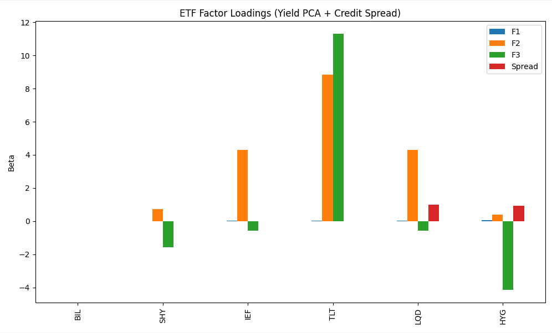
Figure 1 : ETF Factor Loadings (Yield PCA + Credit Spread)

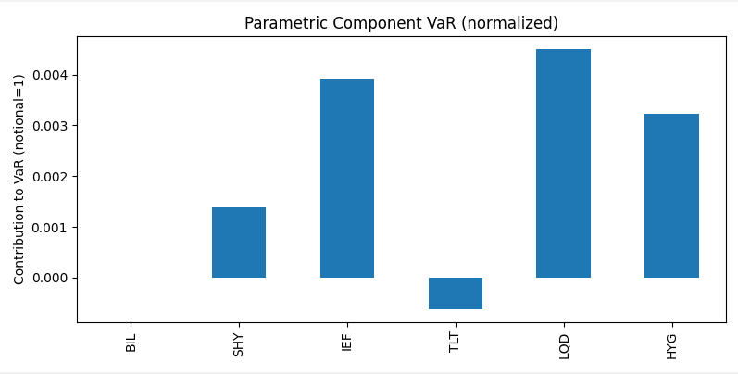
Figure 2 : Parametric Component VaR (Normalized)

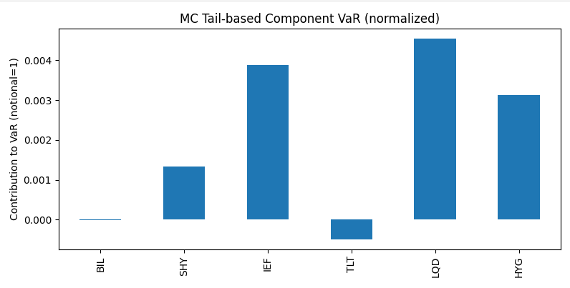
Figure 3 : Monte Carlo Tail-Based Component VaR (Normalized)

